What is a Gesture Dictionary?
A Gesture Dictionary also known as a Personal Communication Dictionary (PCD) or a Personal Gesture Dictionary (PGD) is a document that helps to outline the ways in which an individual communicates. This can be really helpful when working with emergent communicators or individuals with complex communication needs who don’t communicate using methods such as sign language or key word signing, speech, writing or an AAC system.

Why would I use a Gesture Dictionary?
When working with emergent communicators or individuals with complex communication needs, we often see a variety of modes of communication being used including signs and gestures, vocalisations, body movements and facial expressions. It might be a method of communication that they’ve developed independently, or it might take the form of a verbal or physical approximation. Some individuals have learned to use sign or Makaton but because of physical or motor issues they are unable to perform the movement conventionally. In the same way we recognise that repeated use of “da” when the individual is thirsty might mean “drink”, we recognise that consistent use of a particular movement can also carry a particular meaning. Often their communication attempts are subtle and idiosyncratic making them open to misinterpretation. This can lead to frustration and ultimately passivity. To be as a responsive and reliable communication partner, we want to do our best to ensure we don’t miss or misunderstand these communication attempts and that the team around the individual is as consistent in their responses as possible. A communication or gesture dictionary can help to ensure that all of the individual’s communication partners are aware of their communication behaviours with a collective agreement on how to respond to these communicate attempts.

How do I create a Gesture Dictionary?
To create a gesture dictionary, people who know the individual well need to observe and describe their communicative behaviours, determine what these behaviours mean and then agree on an appropriate response.

You can put a gesture dictionary together with three simple columns:
- What is the communicative behaviour (e.g. the sound or movement)
- What does the behaviour mean? What is your interpretation?
- How should the communication partner respond to this behaviour? (e.g. respond according to the situation or respond in a specific way depending on the context)

Here is a great example from Practical AAC:
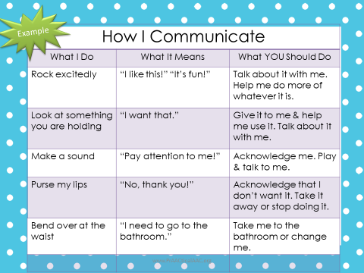

Tips for using a gesture dictionary
Once you have collated the information about your client for your gesture dictionary, make sure that:
- It is somewhere which is easily accessible for anyone who is communicating with the individual, e.g. on the classroom or lounge wall.
- There is a system in place so that if there is a new communication partner, they know that they need to review this information and use this document as a reference point when communicating with them.
- The key people working or communicating with the individual set a review date to check the gesture dictionary remains a true reflection of the individual’s communicative behaviours. It is a working document as communication changes and develops over time.
- It does not need to be created on a fancy template - you can create a table in Word or just handwrite it on some nice paper and keep adding to it over time.
- It could be in booklet or poster form. If you decide to create a booklet or notebook, you can alphabetise the entries to help the user. For example, when Chris bangs the TV, the carer can look up ‘B’ for bang or ‘T’ for television.

On the next page is a TalkLink Template to help you get started. You can personalised it and add borders or different colours to help it reflect the individual’s communication and personality.

References: Carole Zangari: On the Same Page: Helping Team Members Recognize and Respond to Unconventional Communication Signal (Practical AAC April 2018)

Created by Polly Khushal (SLT) May 2020

Communication Gesture Dictionary

(INSERT NAME)

Communication Gesture Dictionaries are useful to provide interpretations of an individual’s communicative behaviour, for communication partners across different environments.

“We cannot shape or replace their behaviour with communication UNTIL we know what their behaviours mean!”

What (INSERT NAME) does | What it means | What you do
e.g. Bangs the TV | Wants the channel changed | Model ‘help’ on core board and change the channel

