

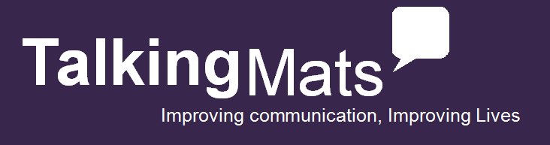**Workshops**

* One full day workshop
* Two half day workshops available (please contact us)

 **Presented by TalkLink Trust and Talking Trouble**

**Fee*:*** *$330 per person, including a Talking Mats Symbol Set of your choice.*

**Could Talking Mats help you?**

Talking Mats® has the potential for use with a wide range of people. It is a visual framework, which helps people think about issues and provides them with a way of expressing their views more easily. Participants have included Occupational Therapists, Dieticians, Doctors, Nurses, Advocacy Workers, Service Planners, Social Workers, Speech-Language Therapists, Care Workers, Teachers, Rehabilitation Assistants, Researchers, Psychologists.

Clients can include people with a learning disability, stroke, dementia, neurological difficulties, mental health issues, the elderly, children and young people.

**Course Format:**

This one-day Foundation Training Course delivered by Talking Mats Accredited Trainers, combines hands-on experience of Talking Mats with role-play, discussion and reflection of the use of the tool in a variety of real-life situations. The morning will provide background information, experience opportunities to use Talking Mats, useful models to think about communication and complexity of language. There will also be film footage of a range of people with communication difficulties using Talking Mats. The afternoon will focus on using Talking Mats in real life situations and planning how to develop its use in participants’ own work environment.

**Registrations can be made on** <https://talklink.org.nz/talking-mats-courses>

*If you would like a course to be held in your area, please email* [*courses@talklink.org.nz*](mailto:courses@talklink.org.nz)

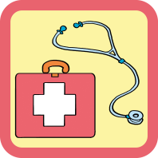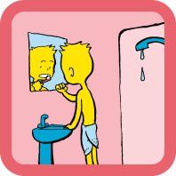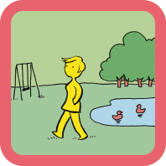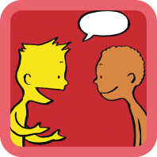

**Looking After Yourself**

Topics - Self-care, domestic life, work & education

**Communication**

Topics – Expression, understanding, relationships, learning & thinking

**Health**

Topics - Health, Mobility & Coping

Resources from Health & Well-being

**Leisure & Environment**

Topics – Environment, leisure away & leisure home

**Early Years**

Aged 3-7

Topics – My body & skills, my wider world, what I do & my support

**Primary**

Aged 5-12

Topics – My body & skills, my wider world, what I do & my support

Resources from Consulting Children & Young People

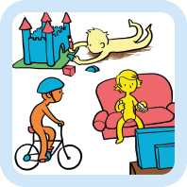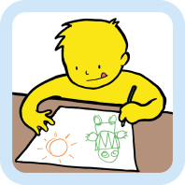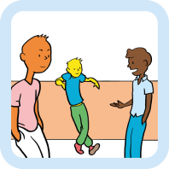

**Secondary**

Aged 12+

Topics – My body & skills, my wider world, what I do & my support

Social Care

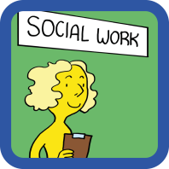

**Social Care**

Topics – You, activities & where you live

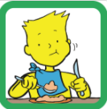

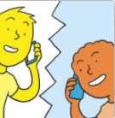

Eating & Drinking

Keeping Safe

**Keeping Safe**

Topics – Your wellbeing, thoughts and feelings, relationships

**Eating & Drinking**

Topics – meals, impact on health, things that might help