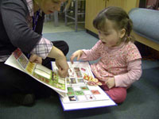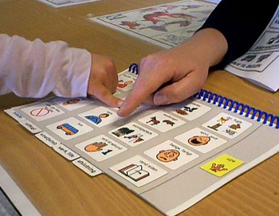

**REGISTRATIONS**

**Date**: Monday 8th of March 2021

**Time**: 9:30am – 2:30pm

**Venue**: Mahurangi College,

7/5 Woodcocks Road, Warkworth.

Parking available on surrounding streets

Follow this link to register online:

<https://talklink.org.nz/creating-communication-opportunities->

Any questions please contact Shauna McCabe

Email: [courses@talklink.org.nz](mailto:courses@talklink.org.nz)



TalkLink

Wahanga Tu Korero

Assistive Technology Services

|  |
| --- |
| Workshop content  · What is Augmentative & Alternative Communication (AAC)?  · A look at some theory and current thinking in the field of AAC  · Exploring a range of practical strategies, resources and ideas that can be used to increase communication skills  · Core Vocabulary:  - What is it?  -Why is it important?  - Encouraging its use.  · Modelling and Prompting  · The skills you need to be a good communication partner  · Practical ideas for classroom activities to encourage and support communication.    and more… |
|  |
| **Cost**  Professionals - $150 per person  Families/Whānau – Free  Morning tea is provided  Please bring your lunch |

A practical one-day workshop for teachers, teacher aides, families, whānau, health professionals and other interested people. This workshop looks at ways to support and develop your student’s communication throughout the school day. Both low tech and high tech options will be explored. Lots of practical tools, resources, tips and tricks will be shared. The learning will be applicable to students of all ages – preschool to high school.

**Creating Communication**

**Opportunities**

Throughout the school day