Process for MoH Funded Communication Assistive Technology Equipment
Pathway to achieve Communication Assistive Technology credentialing.
Supplementary guide to information found here:
http://www.disabilityfunding.co.nz/ems-assessors/credentialled-categories-of-accreditation/communication-assistive-technology-level-1
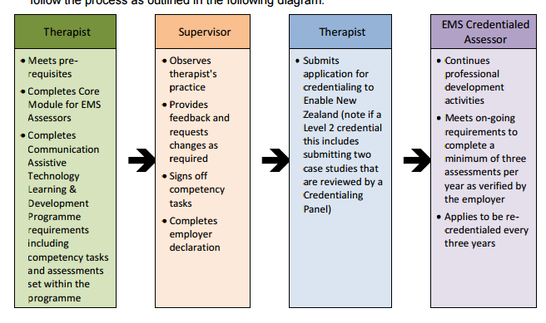
- Therapist meets prerequisites: OT, SLT, VNT

- Log in and/or register on EMS Assessor Online and complete the EMS Core Module http://www.disabilityfunding.co.nz/ems-assessors
  - Create a username and password. This password is unique to EMS Assessor online and managed by Enable New Zealand. Any questions please contact EMS Assessor Helpline on 0800 171 981

- Complete online Communication Assistive Technology Level 1 Learning and Development Programme (CAT Core Modules).

During this process you need to complete the following processes:
  - ATANZ Membership (this is a requirement to be credentialed)

  - Select a supervisor
- How do I find someone to supervise me?
When you register as an EMS assessor, you are required to nominate a supervisor/employer. Your supervisor must be a CATL1 or CATL2 credentialed assessor.
Your supervisor will be registered at EMS Assessor Online www.disabilityfunding.co.nz and they will be able to complete the employer declaration for this credentialed category.
If you are unable to access a supervisor in your workplace you can contact support@talklink.org.nz to request a supervisor to support you with your CATL1 credentialing process.

- Tablet devices:
One consideration when choosing a supervisor is whether or not you anticipate requesting tablet devices. In order to apply for tablet devices as a CATL1 therapist you will need to have the application signed off by a CATL2 therapist employed by the MoH contracted specialist assessment service (TalkLink Trust).

  - Complete an assessment summary and rationale and send this to your supervisor.
    - How do I write the Service Request report required for accreditation?
To become accredited as a CATL1 therapist, you will need to provide evidence to your employer/supervisor that you have the necessary competencies. We suggest completing a written report to justify the equipment you wish to apply for against the EMS funding criteria, which your supervisor can then review. We recommend you use this template for your report. This will support you with structuring the report and help you to demonstrate to your supervisor how the person meets the eligibility and access criteria and that you have considered other equipment options and the rationale behind the equipment choices you have made.
- How do I find out about the different types of equipment?
You can find out about the different types of equipment through TalkLink. TalkLink offer regular Tools Workshops, which are advertised here: https://talklink.org.nz/tools-workshop . You can also source information from suppliers such as DTSL http://assistive.dtsl.co.nz/default.aspx
- How do I access trial equipment?
Along with re-issuable EMS equipment, ATANZ has a pool of trial equipment that is available to ATANZ members for trial. To request equipment please complete CAT Support Request form found here https://talklink.org.nz/support

- Once you have completed the CAT Core Module and your supervisor has approved your accreditation application, Enable New Zealand will email your EMS assessor number to your registered email address as per the details you have recorded in EMS Assessor Online. Remember you need to keep these details up to date.

EMS Funding Processes:

- To be able to make EMS Service Requests you need to follow the Ministry of Health processes. You will need to complete the Ministry of Health Prioritisation Tool training. To do this, you need to register at http://learnonline.health.nz/ - you need to use your EMS assessor number for this. Once you have completed the training, an email will be sent to Enigma notifying them that you can use the Prioritisation Tool and Enigma will provide you with a link to access the tool. Please use your EMS Assessor number for logging into the Prioritisation Tool. To know how and when to use the Prioritisation Tool visit the Ministry of Health website http://www.health.govt.nz/our-work/disability-services/about-disability-support-services/equipment-and-modification-services/prioritisation-tool-resources For assistance logging into the Prioritisation Tool please see these instructions: https://secure.ems.health.nz/ems/assets/resources/Help%20Logging%20In.pdf

- You will also need to find out when to seek mandatory EMS Advice via the Enable New Zealand or accessable Advisory Service. http://www.health.govt.nz/our-work/disability-services/about-disability-support-services/equipment-and-modification-services/prioritisation-tool-resources/consultation-decision-making-and-complaints-processes The Enable Request for EMS advice form is located here: http://www.disabilityfunding.co.nz/equipment/equipment. The accessable Request for EMS advice form is located here: http://www.accessable.co.nz/manuals-forms#equipforms

- To request Ministry of Health funded Band 2/3 Equipment, you will need to log in and use the Prioritisation Tool to determine if Funding is Available, and then make a Band 2/3 Service Request to order equipment. This is done in the Prioritisation Tool by clicking on the relevant link to either Enable New Zealand RTL or accessable OCO. Check the correct website details for the Prioritisation Tool via the Ministry of Health training materials to show you how to use the website: http://www.health.govt.nz/our-work/disability-services/about-disability-support-services/equipment-and-modification-services/prioritisation-tool-resources/using-equipment-and-modification-services-prioritisation-tool

You must check with TalkLink on equipment@talklink.org.nz to determine if there is any suitable reissue equipment available before making your Service Request and if there is please note on the Service Request form that it is reissue equipment.

TalkLink must be consulted before submitting a service request for tablet devices. Please use the TalkLink CAT Support Request form for this consultation. The form can be found here: https://talklink.org.nz/support .Once the consultation is complete and approved this option should be checked off in the Service Request.

- Once you have made a Service Request the equipment will be sent to your nominated delivery address. You need to have your equipment set up and labelled (Enable NZ region) before issuing it to the client. TalkLink will complete this role for both Enable NZ and accessable for the following equipment;
– tablet devices and associated apps;
If Talklink is completing the set-up, please ensure you enter the TalkLink address in the Delivery Address details on your Service Request. Please also send a copy of the Service Request to equipment@talklink.org.nz

- Issuing of Ministry of Health funded equipment requires you to provide documents to the \client and their family
Enable Region: http://www.disabilityfunding.co.nz/__data/assets/word_doc/0015/90600/ENAE212-Care-and-Use-of-Equipment-form.docx
Accessable Region:
http://www.accessable.co.nz/images/moh/equipment/care-and-use-of-equipment-form.pdf

- Complete equipment training – both technical and implementation with your client and their team.
- Who completes the training if I apply for equipment?
The CAT1 therapist is responsible and will need to complete the training for any equipment they have had funded from the Ministry of Health. It is therefore important that you are confident in operating the equipment you are applying for during the trialling, so you can ensure the person (and carers etc) know how to care for and use the equipment to meet their communication goals, as well as where to go for repairs.

- Who manages repairs and returned equipment?
For repairs and equipment returns TalkLink are the Specialist Service managing all Ministry of Health funded communication equipment.
If the equipment is not working please contact repairs@talklink.org.nz or phone TalkLink on 0800 825 554
When equipment is no longer needed please ensure the equipment is returned to TalkLink so they can make it available for reissue.
- How do I maintain my maintain accreditation?
Every 3 years, you will need to renew your accreditation through Enable. To maintain your accreditation, you are required to complete 3 assessments where you have considered assistive technology each year over the 3 year cycle. Each time you make an application, you need to write a report to show the rationale for the equipment you wish to apply for and retain this for your clinical records should you be audited.

