Communication Passports

What is a communication passport?
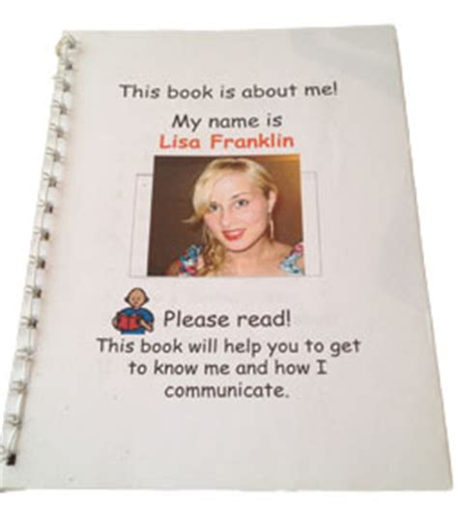
A communication passport is an individualised booklet about a person. It gives the person a voice to share key information about themselves, to help others get to know him or her. The passport can be used by new people (e.g. new care givers, health professionals or friends) to get to know this person better. The passport is a quick way to understand things that the person cannot communicate about themselves, e.g. how best to support understanding, dietary requirements and medication information as well as likes and dislikes and topics they like to chat about. Communication passports can be used by children and adults as they are always highly personalised. They are very useful when transitioning between services or when new people come into their life.

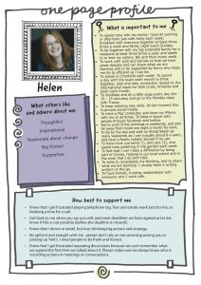
How to create a communication passport?
Try to get the person to decide what should go in the passport as much as possible, so that it is a reflection of their own views and preferences.
Write the passport from the person’s point of view - make the dialogue chatty rather than professional.
Draw together information from past and present and from different contexts so that it paints a holistic picture of the person.
As time goes by things can change, so please update it when required.
Remember to present the person positively – not just as a set of ‘problems’ or medical needs.
Feel free to add pictures, photographs and additional sections to help make it a very valuable personal resource. Equally, feel free to delete any sections which do not apply.

When to use a communication passport?
Communication books are useful when there are new people around, e.g. transitioning to a new school, visiting the hospital, moving into a retirement home, etc. Make sure you have it in a really visible place for new people to look through, e.g. a new nurse starts his shift and the communication book is sitting on a table at the end of the bed, so he can quickly read through it while introducing himself and have a few ideas on how best to communicate and some topics that are good to talk about, as well as some things that the person does not like.

Who can make a communication passport?
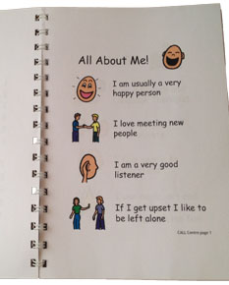
Anyone can make one! The most important thing is to involve the person as much as possible when choosing the content and how it looks – adding borders, colours, photos, etc. You can hand write this or type/edit it on a computer. Or you could create your own passport using a scrapbook or a clear file. There is a full template and a short one page template at the end of this document which you can edit. If you don’t like the symbols, feel free to delete them and add your own photos. You could also add a contents page at the start of the book with the title of each page in order to find info quickly.

Ministry of Health also have a free template Health Passport available for download here, which you can carry with you when you go to hospital or when you use other health and disability services, such as your GP or a new carer: https://www.health.govt.nz/your-health/services-and-support/health-care-services/health-passport

References:
https://www.specialneedsjungle.com/one-page-profile-can-improve-special-needs-childs-life/ and
https://www.communicationpassports.org.uk/creating-passports/

Created by Jessamy Bell (Speech Language Therapist) on 10/04/2020

Name’s Communication Passport

Insert photo

Please read this booklet about me
It will help you understand me and to help us with communication.

Last updated:
A bit about me

Insert photo

My name is

I like to be called

My birthday is on

I live at

In an emergency, please contact

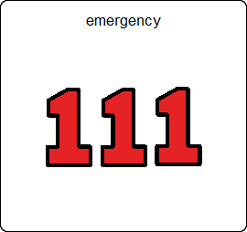
Key things to know about me

I need [e.g. medications, walker, glasses/hearing aides, etc]

I mustn’t [e.g. eat alone as there is a risk I could choke]

I am allergic to

I need help with
[personal cares like going to the bathroom, dressing, etc you can help me by…]

My vision is

My hearing is

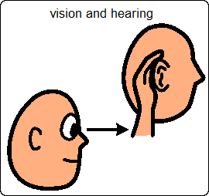
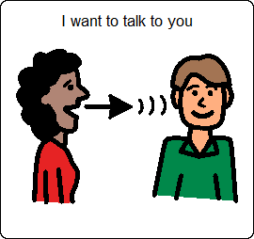
How I communicate

I speak [insert languages]

The main language I speak is

Understanding other people

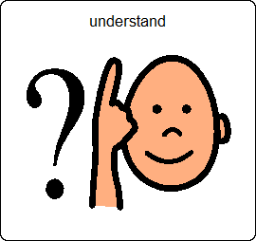

Getting my own message across

How you can help me communicate:

Please DO  [Give me time to process what you Say, keep things short and sharp, look at me and make sure I can see you, come to my level to make eye contact, speak clearly and slowly, include me in conversations about me - I can understand what you’re saying, speak WITH me! I like it if you have a conversation with me before, during and after my morning routine and throughout the day, hold up two items to give me choices E.g. my outfit for the day. I will make a choice by looking at what I want, show me pictures to support my understanding (e.g. of places I’m going to visit, or of my family), use my communication book to support my understanding, etc] | Please DON’T  [Talk over me, walk away or face away from me when you are talking to me or about me, talk in a baby voice or talk down to me, shout at me – I don’t have a hearing impairment, etc]
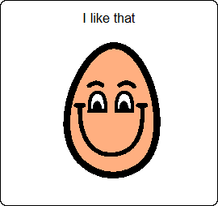
Things to I like do

Things I like to talk about

[How I’m feeling, family, sport team, photos on my wall, work, school, TV shows I like, my hobbies, gardening, music, church, news, food, drink, holidays, etc]

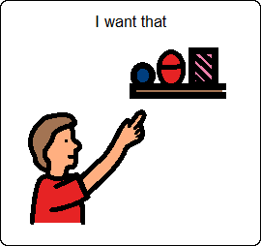
Important/favourite things I may want to request

Things I don’t like

[Being touched without warning, loud music, being talked to in a baby voice, etc]

Places

I live now in

My family live

I was brought up in

I used to live in

I’ve travelled to

I like to go out to

Places I’ve been

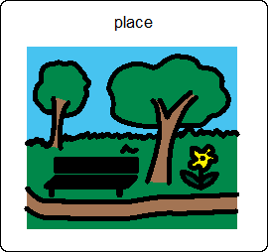
People who are important to me

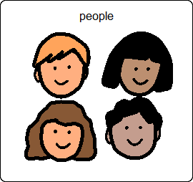
[My sister’s name is Chelsea and she lives down the road from me. We see each other every few days, etc]

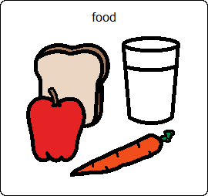
Eating and drinking

Food

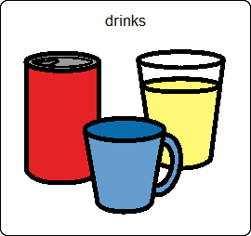
Drink

Things you need to know about my eating and drinking safety and allergies

Special moments and events in my life

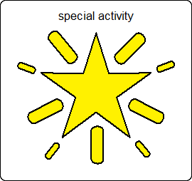
My work / My school/kindy

[Customise for your situation and delete the appropriate visual:
Work = qualifications, profession? Where? What? How long I worked there?
School/kindy = name of school, teachers names, friends, favourite subjects, etc]

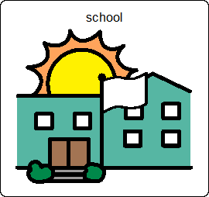
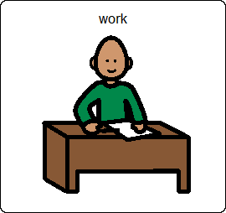
My cultural and spiritual identity

I was born in

I am [insert the culture, religion or spiritual tradition you best identify with]

Important things you should know about this:

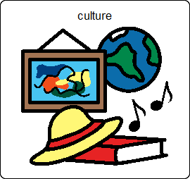

Important things you should know about me:

How I communicate:
My name is

Insert photo

How you can help me understand what you are saying:

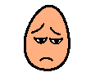

Things I like:

Things I don’t like:

Topics I like to talk about:

Example of a communication passport on Grid3 software on a high tech communication device:
