Literacy Instruction for Children with

Complex Communication and Learning Needs

Sally Clendon, PhD

WHEN: This practical two-day course will be held in Auckland on 8th and 9th April, 2021
9.30 am – 4:00 pm each day
WHO FOR: These workshops will be highly relevant to teachers, RTLBs, SENCOs, teacher aides, speech-language therapists, occupational therapists, parents, and others who work with or support children with complex communication and learning needs (e.g., children with cerebral palsy, autism spectrum disorder, Down syndrome).
COSTS: $500 for professionals for both days, $280 for one day
$200 for family members for both days, $100 for one day
CATERING: Morning tea and lunch provided.
All prices are GST inclusive.
REGISTER: To register online, please go here
https://talklink.org.nz/literacy-instruction-for-children-with-complex-communication-needs

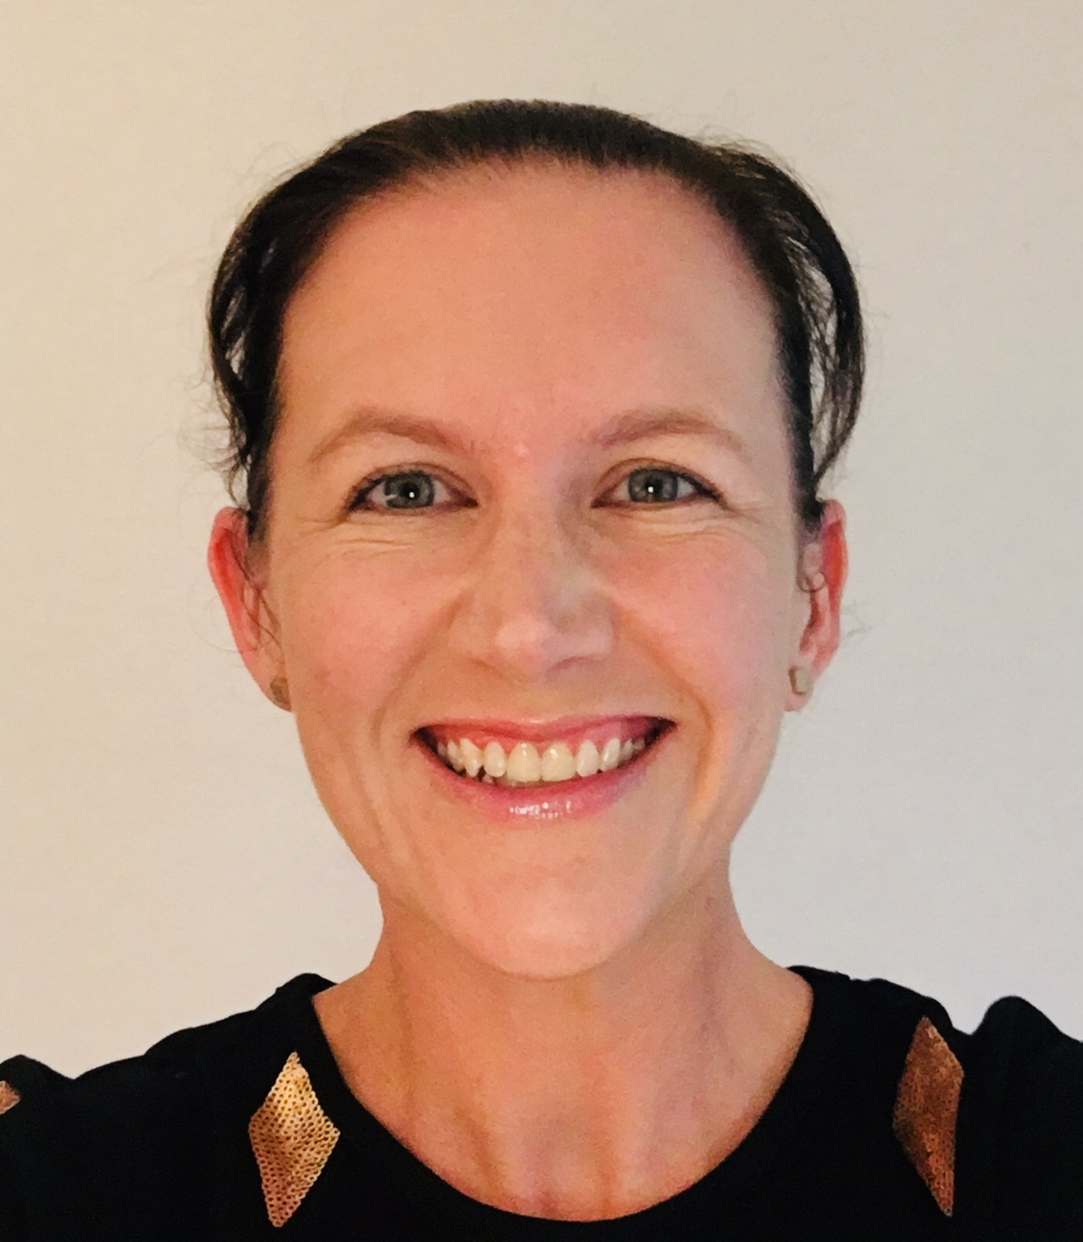 | Sally Clendon, PhD is a speech-language therapist with expertise in literacy instruction for children with complex communication and learning needs particularly those who use augmentative and alternative communication (AAC). Sally completed her PhD at the Centre for Literacy and Disability studies at the University of North Carolina at Chapel Hill in 2006. Since then Sally has held academic appointments in Australia and New Zealand, whilst also engaging in a variety of consulting work. Sally presents nationally and internationally and has worked with several schools across New Zealand to implement a comprehensive approach to literacy instruction for their students. Sally looks forward to sharing her passion for literacy and all that she has learned from working alongside teachers and students to ensure that ALL children have access to the communication and learning opportunities they need.

Day 1 – Literacy Instruction for Children who are Emergent Learners
Emergent literacy is the process that children move through from birth as they weave together knowledge about language and literacy (Dickinson & McCabe, 2001). This includes code-related skills such as phonological awareness, print awareness, alphabet knowledge, and emergent writing; and oral language skills such as inferential language and vocabulary (Whitehurst & Lonigan, 1998). Knowledge in these areas develops in an integrated manner to provide children with a strong foundation that has been shown to be critical to later literacy learning success (Dickinson & McCabe, 2001).
All children are readers and writers including those with complex communication and learning needs. We need to pinpoint where they sit on the continuum of literacy learning, identify their strengths and their areas of need, and then work together to differentiate instruction and optimise their learning outcomes. This workshop will equip attendees with a toolbox of ideas and strategies for maximising communication and literacy learning for children with complex communication and learning needs.
The workshop will cover:
- The emergent literacy model
- Guiding principles for facilitating emergent literacy learning
- The importance of access to a comprehensive augmentative and alternative communication (AAC) system for children with complex communication needs
- Specific strategies for creating print-rich environments, facilitating shared storybook reading interactions, providing emergent writing opportunities, and building important skill areas such as print concepts, phonological awareness, and alphabet knowledge
- Software, apps, and hardware available for supporting emergent literacy development
- Ideas for older students who are emergent learners
Day 2 – Literacy Instruction for Children who are Early Conventional Learners
This workshop will describe the rationale and principles underlying a comprehensive literacy approach and how it can be applied to children with complex communication and learning needs. This workshop will focus on early conventional literacy learning – so shifting focus from children who need to build their emergent literacy understandings and language skills (covered in Day 1) to a focus on children who can engage and benefit from more formal literacy instruction.
The workshop will cover:
- The Whole-to-Part Literacy Model (Cunningham, 1993)
- Guiding principles for facilitating conventional literacy learning
- Specific strategies for supporting development in four key learning areas: comprehension strategies, word identification (decoding and sight words), self-selected reading, and writing
- Software, apps, and hardware available for supporting early conventional literacy development
- Ideas for older students who are early conventional learners
Participants may choose to attend Day 1, Day 2, or both sessions. Session outlines are above. To register please select the appropriate form at the end of the webpage e.g. school/organisation choose professional. Please indicate which sessions you would like to attend using the drop down menu.
No refunds will be given if cancelled within 5 days of the course running. Payment must be made prior to the course date.

